  


**UNIVERSIDAD NACIONAL AUTÓNOMA DE MÉXICO**

**FACULTAD DE INGENIERÍA**

**Subject:** Computación Gráfica e Interacción Humano Computadora

**Group:** 5

**Semestre:** 2022-2

**User Manual**

**Deadline:** 26/05/2022

**Professor: José Roque Román Guadarrama**

**Students:**

* **Colin Santos Luis Froylan**
* **Najera Noyola Karla Andrea**

# What is this manual for?

This manual is for those people who have already performed the instructions correctly written in the attached setup manual. This manual is written with the intention of giving knowledge of what the user must enter and view in the program, as well as to prevent the wrong interactions with the program resulting in errors or unexpected behavior.

This manual is NOT intended to configure the program or the run/compile environment. For that topic, there is the configuration manual.

In summary: This manual is aimed at the user learning how to use this software.

**It is highly recommended that you have read the project configuration manual before continuing to read the user manual.**

# Requirements

* All requirements specified in the configuration manual.
* Have followed the steps described in the project configuration manual to the letter.
* Preferably, an AMD processor, but may work in Intel.

# About the program

## What is this software?

This is a three-dimensional environment with elements made in a voxel-art style based on the Persona 5 video game and on the real Shibuya crossing in Japan, as well as showing animations of some of these elements on the stage, which can be explored at will thanks to the implementation of a camera with free movement, aerial camera or fixed to the floor camera. Likewise, an audio library is incorporated for the playback of background music while the program is running, which allows listening to the song "The Whims of Fate" from the aforementioned video game in an infinite loop while the software is running, and also plays a 3D sound by triggering it with a command described in a later section.

We have a Skybox, initially given in class by the teacher, but modified to give a "voxel" aesthetic according to the scenario shown. Likewise, the floor on which the elements are shown was also given by the teacher in lab class, but the texture that covers the floor was modified to properly display the elements and quickly identify that it is an urban crossing where people and cars can pass, as well as a nearby train that goes around the buildings, and that travels over railroad tracks.

## Commands available to the user

Some keys are assigned with different functions (mainly related to animations). Here, we describe the keys used by the program and the functions they have.

### Program flow control

* Esc key: Ends the execution of the program.

### Camera control keys

* Mouse Movement: Change viewing angle from a fixed point without changing camera position.
* Mouse wheel forward: Zoom In.
* Mouse wheel backwards: Zoom out.
* W key: Move camera forward.
* S key: Move camera backwards.
* A key: Move camera left.
* D key: Move camera to the right.
* C Key: Activate camera fixed to the XZ plane (camera tied to the floor).
* K key: Activate aerial camera.

### Animations

Note: The animations described here will be described in depth in later sections. All the animations described here are disabled by default, except for the animation of the key 7.

* Key 0: Start/stop sunlight animation.
* Key 1: Enable/reset and disable clock animation.
* Key 2: Enable/reset and disable train animation (Cabin and Wagon).
* Key 3: Enable/reset and disable truck animation.
* Key 4: Start/stop UFO and abduction animation.
  + O Key: UFO and abduction animation restart.
* Key 5: Start/restart slap and celebration animation.
* Key 6: Start/stop conversation animation with speech bubbles.
  + P Key: Restart conversation animation with speech bubbles.
* Key 7: Enable/disable Morgana running animation (enabled by default).
  + L key: Stop and restart animation of Morgana running.

### Light control

* F key: Turn on the spotlight light of the beacon in front of the Magnet building.

### Scenery control

* N key: Switch between skyboxes.

## Elements on stage

We list the following elements and place a photo of them, as well as a brief explanation of their animations (if applicable), but it is better that the user visualizes the animations, although these will be detailed in greater depth in the next section.

|  |  |  |  |  |
| --- | --- | --- | --- | --- |
| Element name | Reference Image | Description | Location | Animation(s) |
| Skybox |  | This is a texture that covers the environment. Gives a feeling of a city at sunset. | Offstage. | N/A |
| Alternate skybox |  | Covers everything around the stage. It looks like it's composed of squares, so that it goes according to the voxel-art style. | Offstage, when you press N. | N/A |
| Floor |  | This covers the entire floor. Describes a pedestrian and car crossing in the dark parts, the green parts are flora areas, the dark gray parts are sidewalks where buildings are located, the light gray parts are the train route and the yellow part is a desert. | Due to its nature (a texture as the basis for the environment), it is found all along the interactive part. | N/A |
| Punctual illumination (Sun) | Appreciable in the different objects that are shown. | This element grants illumination simulating a Sun. | Without animation: In the middle of the stage.  With animation: Going through the stage from one extreme to another. | Key 0: Travel the stage up and down in a circumference route. This gives the day/night effect. Can be stopped, but not restarted. |
| Q-Front Building |  | This building is, in a frontal part, round, and very large in its dimensions. It has a blank screen and many windows, as well as an access door in the curved part. | At the bottom left of the map. | N/A |
| Magnet Building |  | Similar in dimensions to the Q-Front building. This building is made up of several buildings and contains a lot of advertising space. | At the top left of the map. | N/A |
| Lighting beacon |  | It has a spotlight-type lighting source that is activated or deactivated by the user. | In front of the Magnet building. | N/A |
| Truck |  | A small truck based on Morgana's alternate form from Persona 5. It has 4 spinning wheels on the bottom linked by hierarchy. | Without animation: Bottom right corner of the stage.  With animation: Going around all the right half of the stage. | Key 3: The truck turns on its lights, spins its wheels, and travels through the right half of the environment (in straight lines). When circling certain parts, it performs a rotation to the direction of the path. Jumps at certain points on its path. |
| Station entrance (turnstiles) |  | This is the entrance to the train station.  In the front part it contains decorative bushes, and it has steps and turnstiles. It has a dispenser inside. | Top right of the stage. | N/A |
| Train Station |  | The interior of the train station. It has a huge clock on the top. The blue boxes are glass, and contain seats for waiting, as well as boards for the following trains. | Top right of the stage. Behind the turnstiles. | N/A |
| Clock hands |  | The minute and hour hands of the train station clock. | Inside the train station, raised in height and before reaching the waiting room. | Key 1: The minute hand moves clockwise around the clock. The hour hand advances 1/12 the speed of the minute hand. |
| Station waiting room |  | The place where users wait patiently for the train. It has 2 pillars near the wall that distinguish the beginning of this room, as well as seats to make the wait more pleasant. | Deepest part of the station. | N/A |
| Train tracks |  | These are wooden tracks on which the train moves. | Along all the light gray sections of the floor. | N/A |
| Train |  | Composed of a green cabin and a green wagon. | Without animation: Above the waiting room.  With animation: In some light gray section of the map, above the tracks. | Key 2: Travel a route from the station to the same station, passing through the edges of the map (in the light gray parts with tracks). |
| Hachiko Statue |  | Emblematic statue of Shibuya that recreates a canine that was loyal to its master. | To one side of the entrance to the station. | N/A |
| UFO |  | A UFO that comes from the video game Persona 5 and is associated with the character Futaba. | In the heights. Near the pyramid. | Automatically rotates.  Key 4: Approaches above Futaba and abducts her as it rotates and turns on a green spotlight. After a while, Futaba comes back. |
| Pyramid |  | A pyramid whose existence is justified because it is closely related to the character Futaba and her view of the world. | Bottom right of the map. | N/A |
| Akechi |  | He is a villain from the game. He works as a detective, dresses formally, and hates Joker (but also loves him). | Besides the station | Key 5: After Joker gets slapped, he will celebrate raising his arms.  Key 6: A speech bubble will come out of his head. |
| Ann |  | Is a main character in the game. She has a dangerous temper and wants to slap Joker in the face. She wears her high school uniform, but with a flashy sweatshirt. | In front of Joker, besides the station. | Key 5: She will slap Joker 2 times with her right arm.  Key 6: A speech bubble will come out of his head. |
| Futaba |  | One of the main characters of the video game. She wears glasses, red headphones, and has a long orange hair. | Under the pyramid. | Automatically, she is "arguing."  Key 4: When the UFO reaches her position, Futaba rises and becomes smaller. After a moment, she descends and returns to her normal size. |
| Joker |  | He is the protagonist of the video game. He wears glasses and has messy hair. He wears his school uniform. | In front of Ann, besides the station. | Key 5: He Receives a slap from Ann and this turns his head.  Key 6: A speech bubble comes out of his head. |
| Morgana |  | It is a humanoid cat that can speak. It is dressed in a thief outfit. | Next to Joker and Ann, near the station. | Key 6: A speech bubble comes out of its head. |
| Shadow Morgana |  | It's Morgana with her paws like she's running. | In the center of Shibuya crossing. | Key 7: She starts running in circles, raising and lowering her arms. |
| Dialogue balloon |  | It is a balloon that indicates that something is being said. | Without animation: It’s not visible.  With animation: Above the heads of the characters. | Key 6: It appears on top of the characters (except for Futaba) to simulate that they are arguing. |
| Container circle |  | It is a circle under some trees. Covered by shrubs and metal bars. | Close to Hachiko and the station. | N/A |
| Trees |  | It is a tree with apples and roots. | In the green areas (bottom of the map). Also, in container circles. | N/A |
| Shrubs |  | It is a shrub with yellow flowers. | In the green areas (bottom of the map). | N/A |
| Yellow plants |  | It is a squared yellow flower. | In the green areas (bottom of the map). | N/A |

## About the animations

We have 8 animations in total, although some are more complex than others, and are based in different animation techniques, as some are based on advanced animation, others on basic animation and there is an animation using keyframes.

## Animation 0: Sunlight moving

This animation is based on a circle path of the sun on the X and Y axes, simulating a day and night path. The Sun is a punctual light, although there is always a directional light. When the sun is above the stage it moves slower, and when it is below the stage, it moves faster. It is activated with the 0 key and the change in shadows and lighting can be gradually seen. Activates/pauses with key 0. Cannot be restarted.

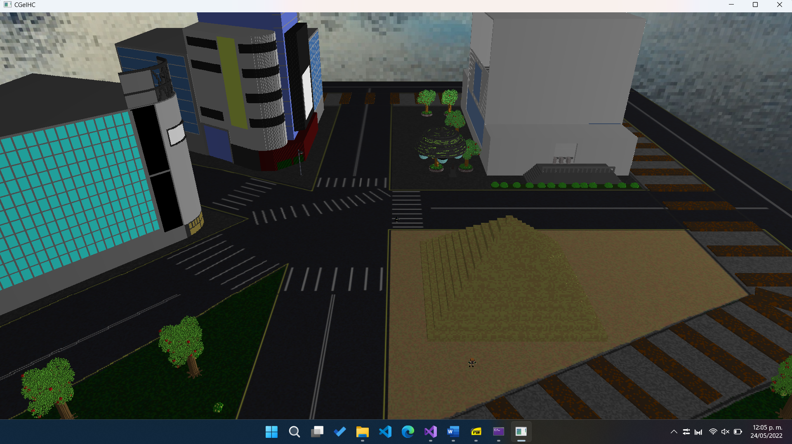

Initial position of the Sun causing shadows.

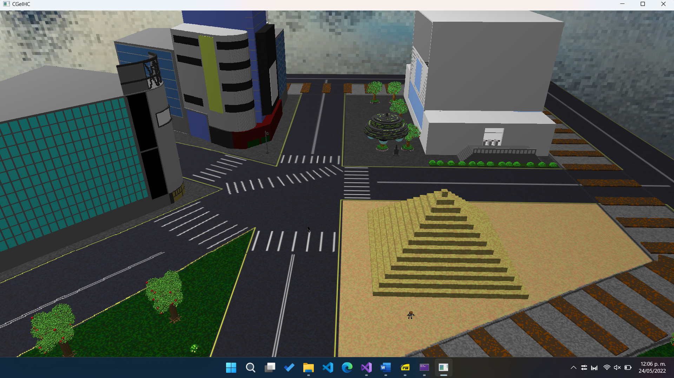

A more advanced position of the sun. Lighter colors are perceived on stage.

## Animation 1: Station Clock Animation

This animation is simple, as it consists of the minute hand at the station turning and the hour hand turning at one twelfth of the speed of the minute hand. It is activated or paused and restarted with the key 1.

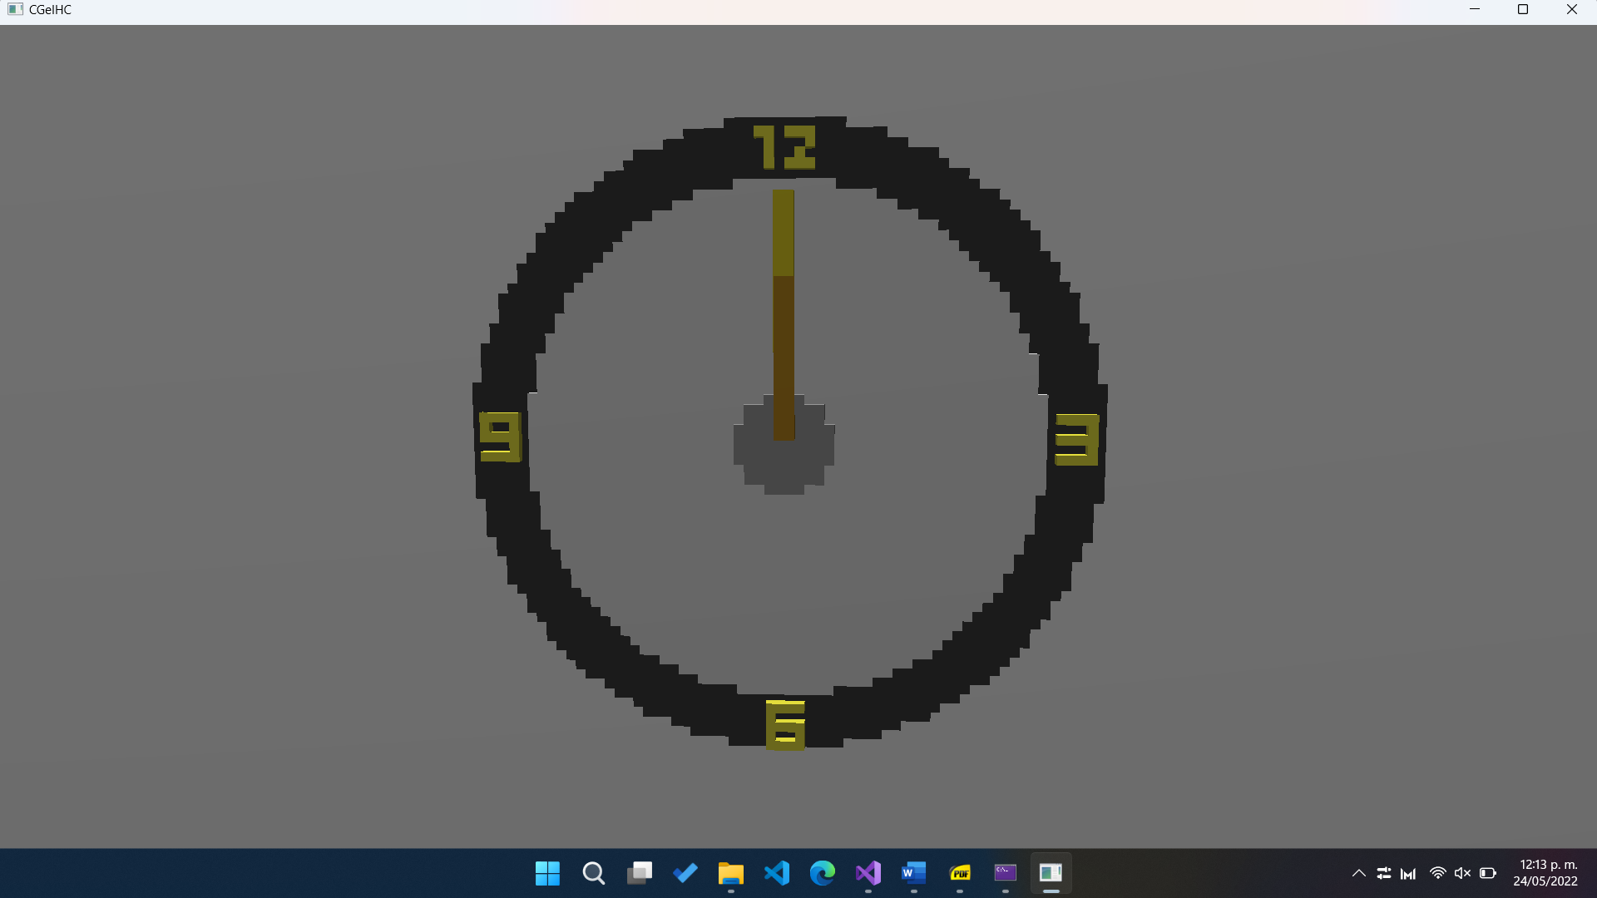

Initial state of the clock

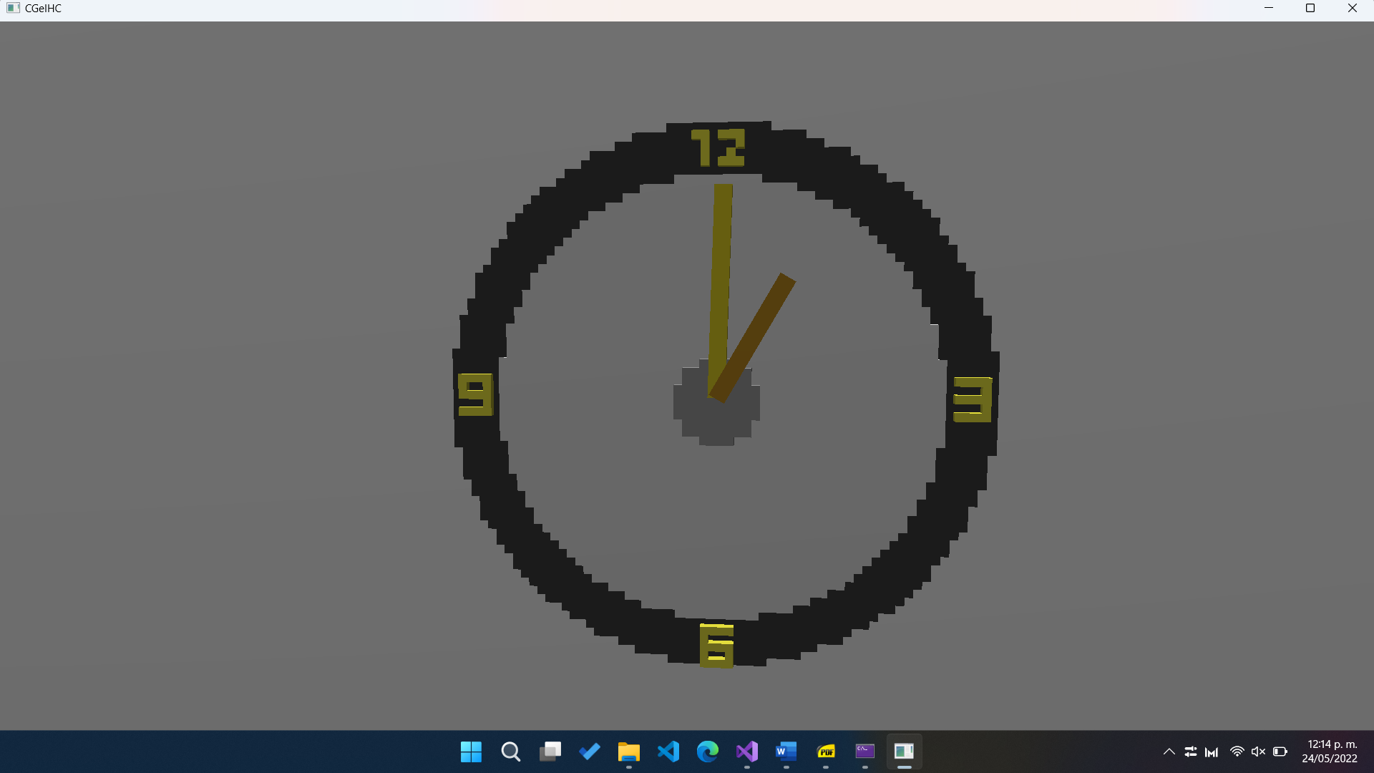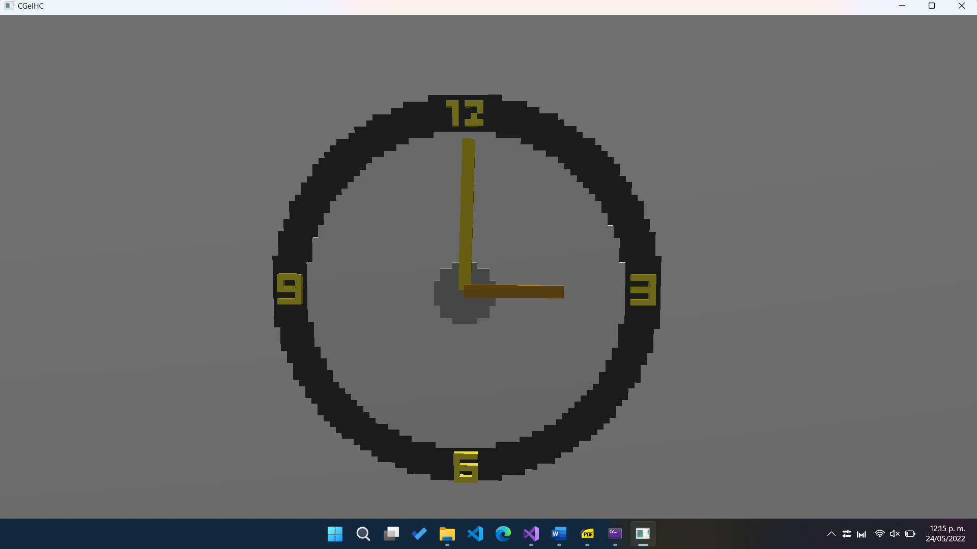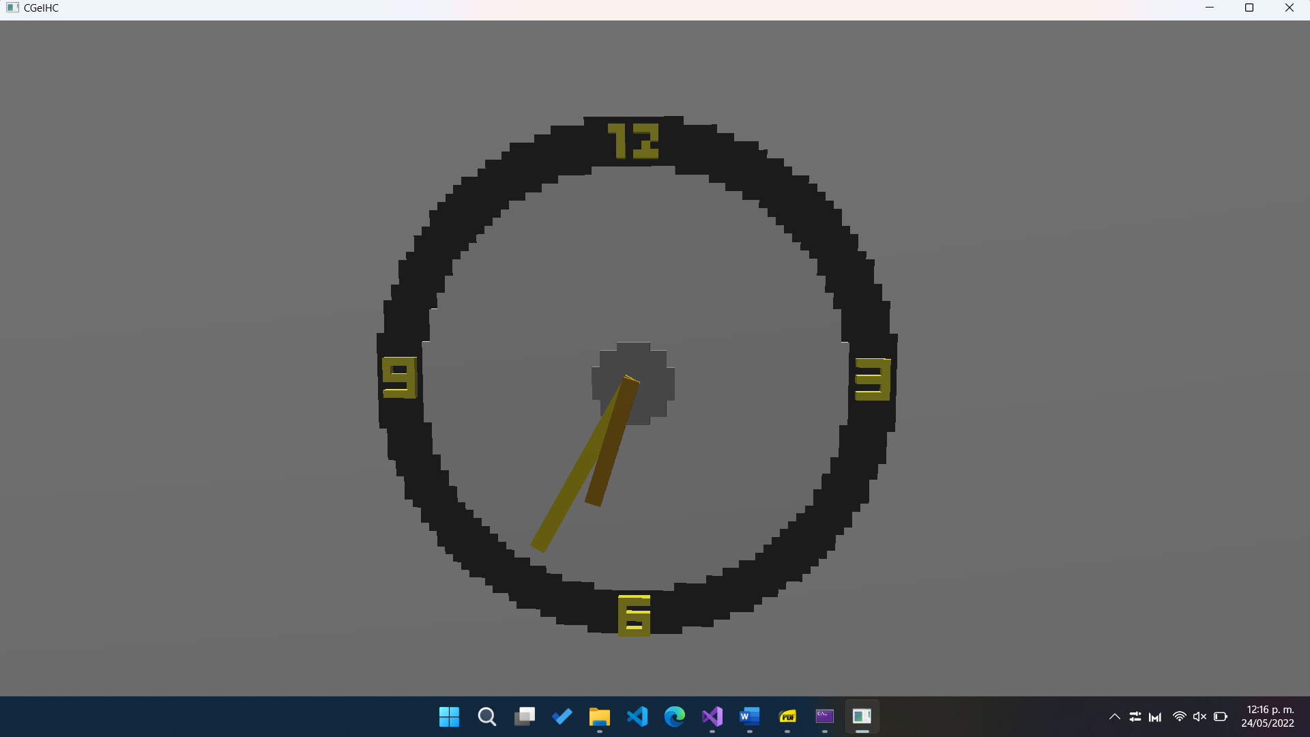

Assorted clock positions marking 1:00, 3:00 and 6:40, approximately.

## Animation 2: Moving Train

In this animation we have 2 models that move along all the train tracks in an anti-clockwise direction. The models are the cabin and the wagon. The route they follow is on top of the train tracks throughout the entire environment, making 90 degree turns or about 20 degrees for a certain part below (the part between the pyramid and the green area in the lower right quadrant). Activate or pause and restart with key 2.

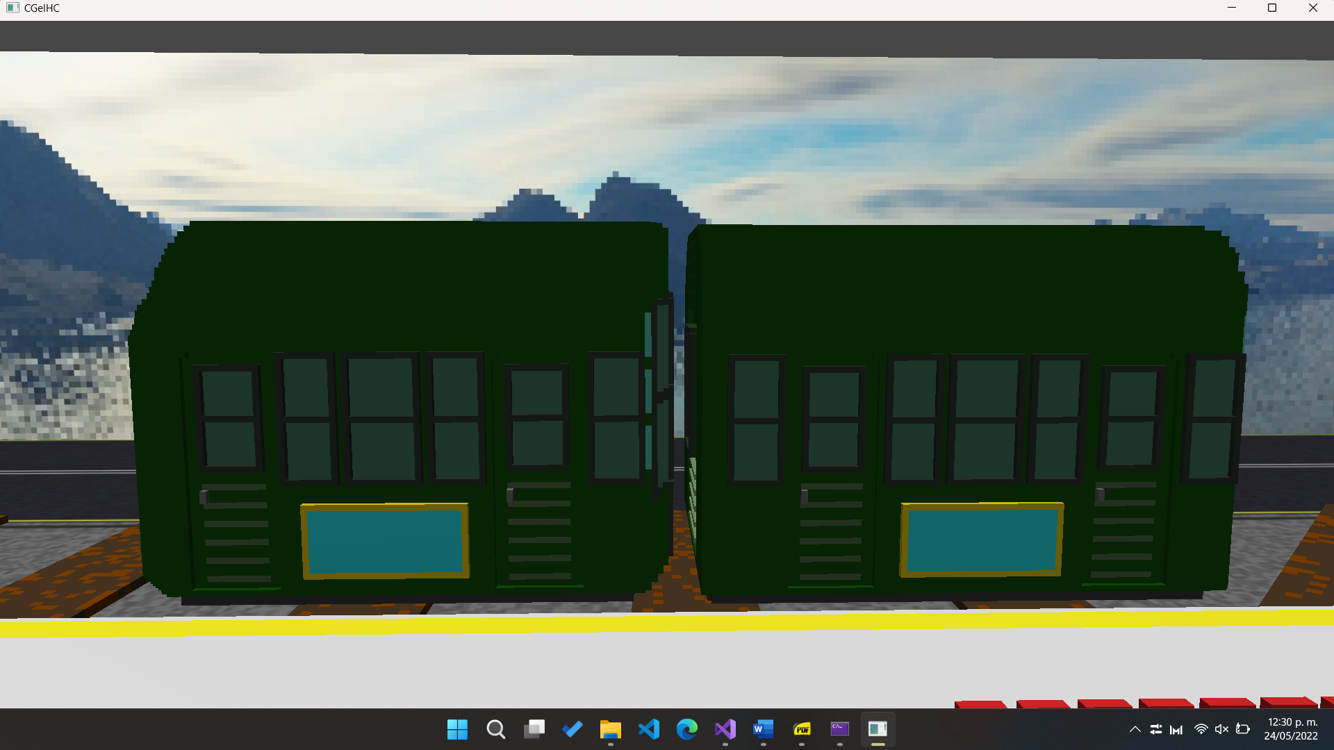

Initial position of cabin (left) and train wagon (right).

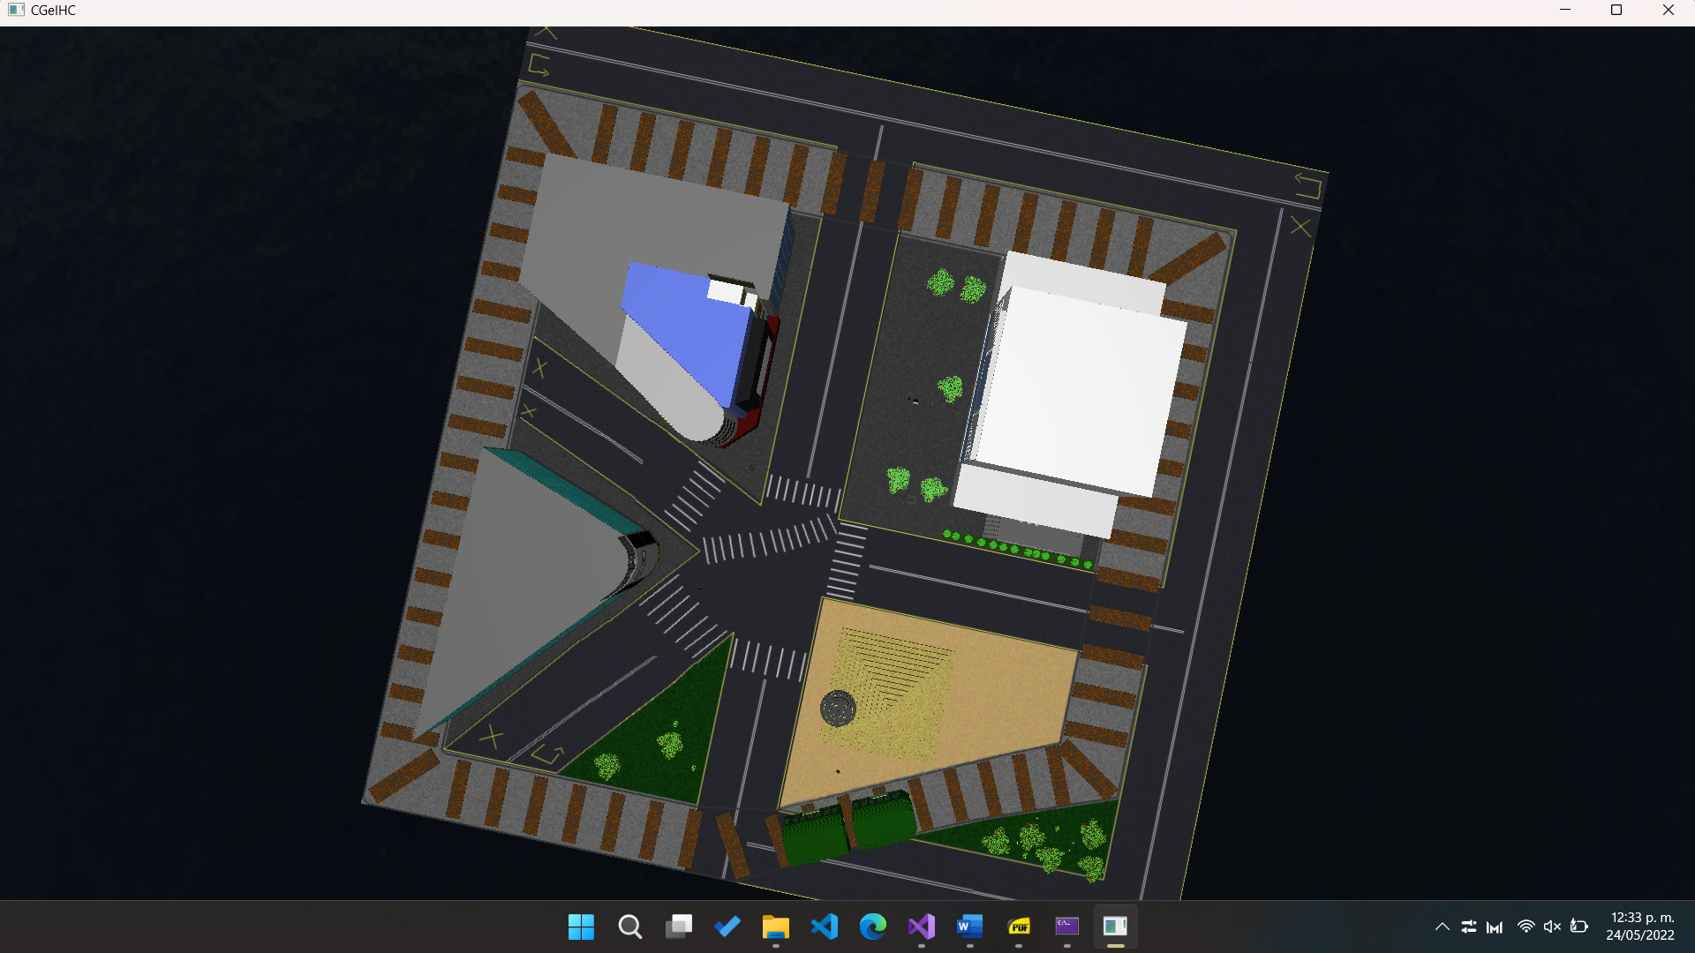

Aerial camera capture of the train and the wagon in the section that divides the pyramid and the green area.

## Animation 3: Moving Truck

This animation consists of the truck turning on 2 lights (punctual light) in its headlights, going up (and making small jumps in which it turns off the lights for an instant), turns to the left when it reaches the top and moves to the left of the map, when it reaches the middle, it turns to the south of the environment and runs in a straight line along the stage while jumping, finally turning to the right to its initial position and the process is repeated. It can be activated or stopped and restarted with key 3.

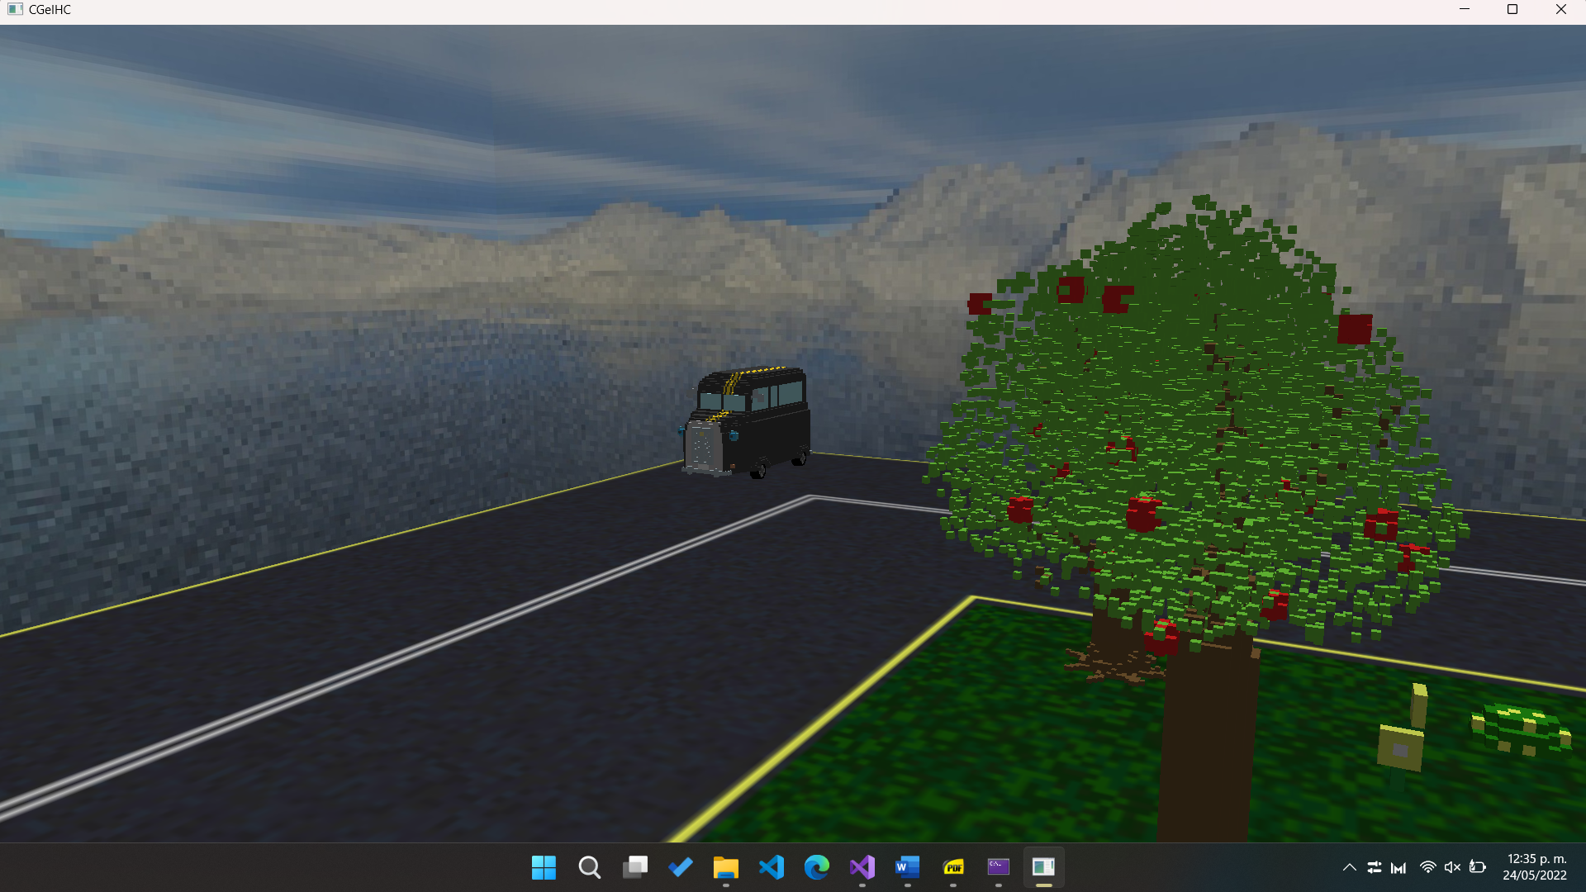

Truck in starting position, in the lower right corner of the stage. Near a green area.

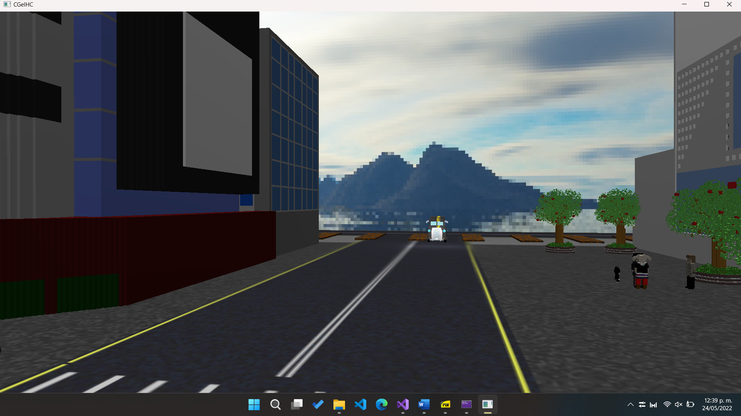

Truck between the Magnet building and the train station, near the tracks.

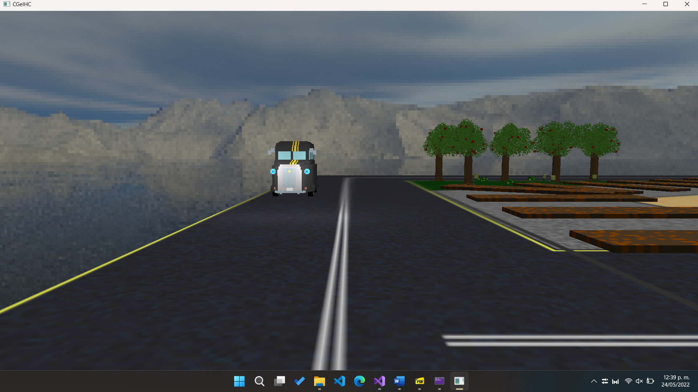

Truck near home position, with lights on and moving.

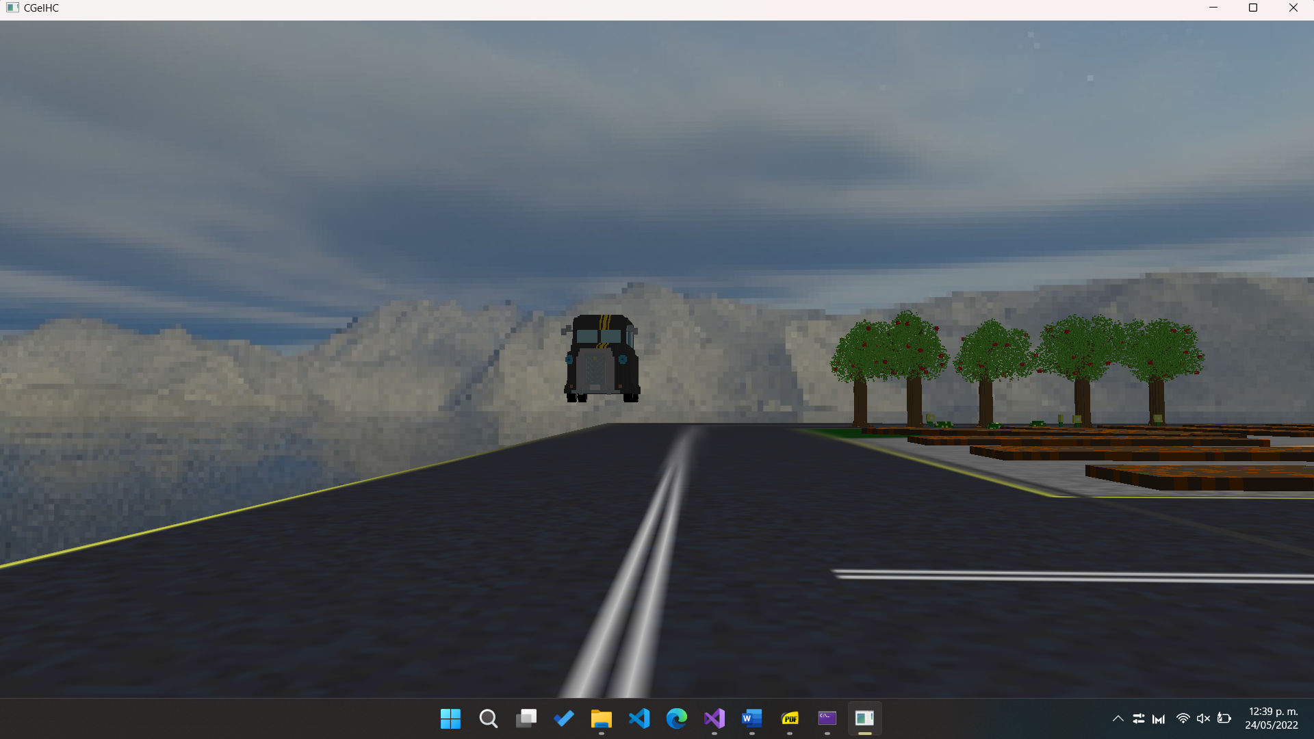

Truck jumping with lights off.

## Animation 4: UFO

In this animation the UFO starts to move towards Futaba's position (high in the air) and rotates even faster when its moving. Once it reaches Futaba's position, a green spotlight appears and Futaba starts to rise towards the UFO while its scale decreases (Futaba becomes smaller). At the end of the abduction, the UFO returns Futaba to her original scale and height, and then it returns to its original position. It can be activated/deactivated with the key 4, as well as can be restarted with the O key.

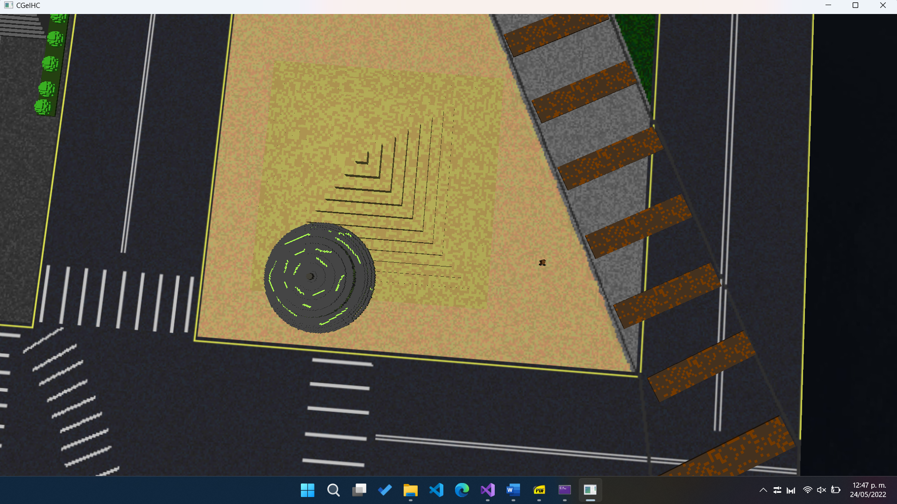

Initial position of UFO and Futaba seen from above.

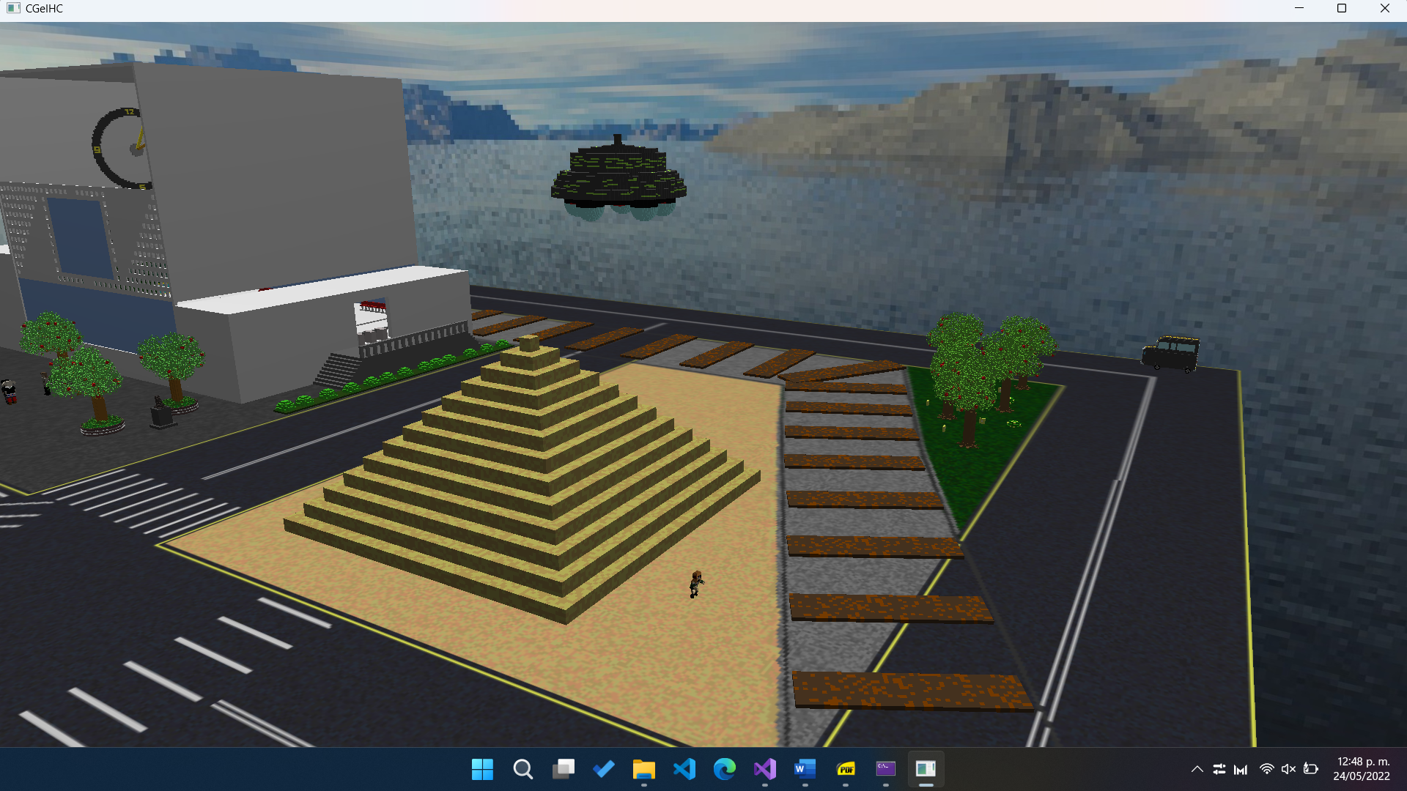

UFO approaching Futaba's position.

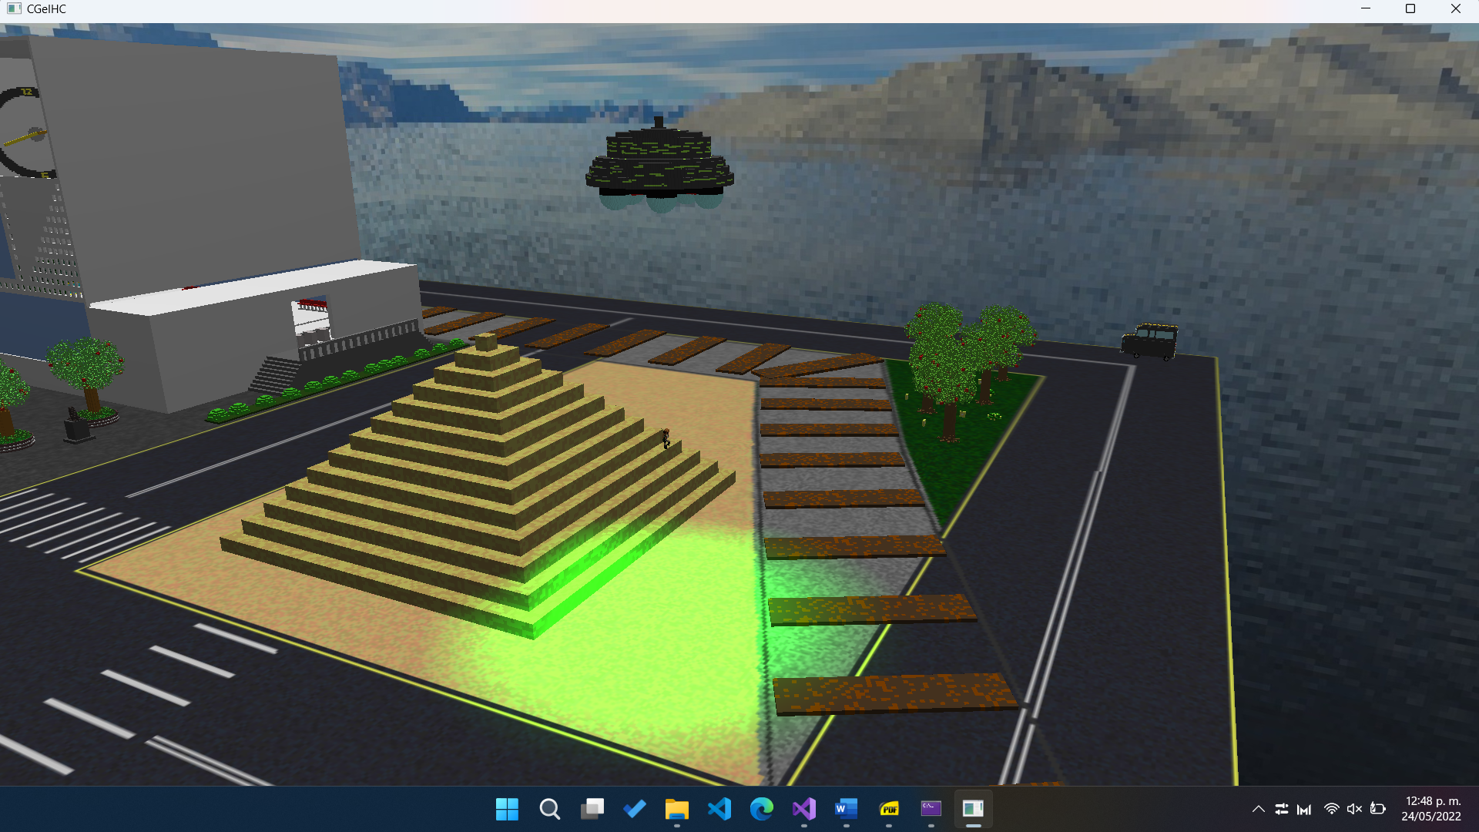

UFO abducting Futaba. A green spotlight can be seen.

## Animation 5: Slapping Joker

Ann raises her right arm and directs it towards Joker. When touching Joker's head, he turns his head to the right side as Morgana yells "Looking cool, Joker". At the end of the slaps, Akechi celebrates by raising his arms. This animation is made with keyframes. It can be activated or stopped and restarted with the key 5.

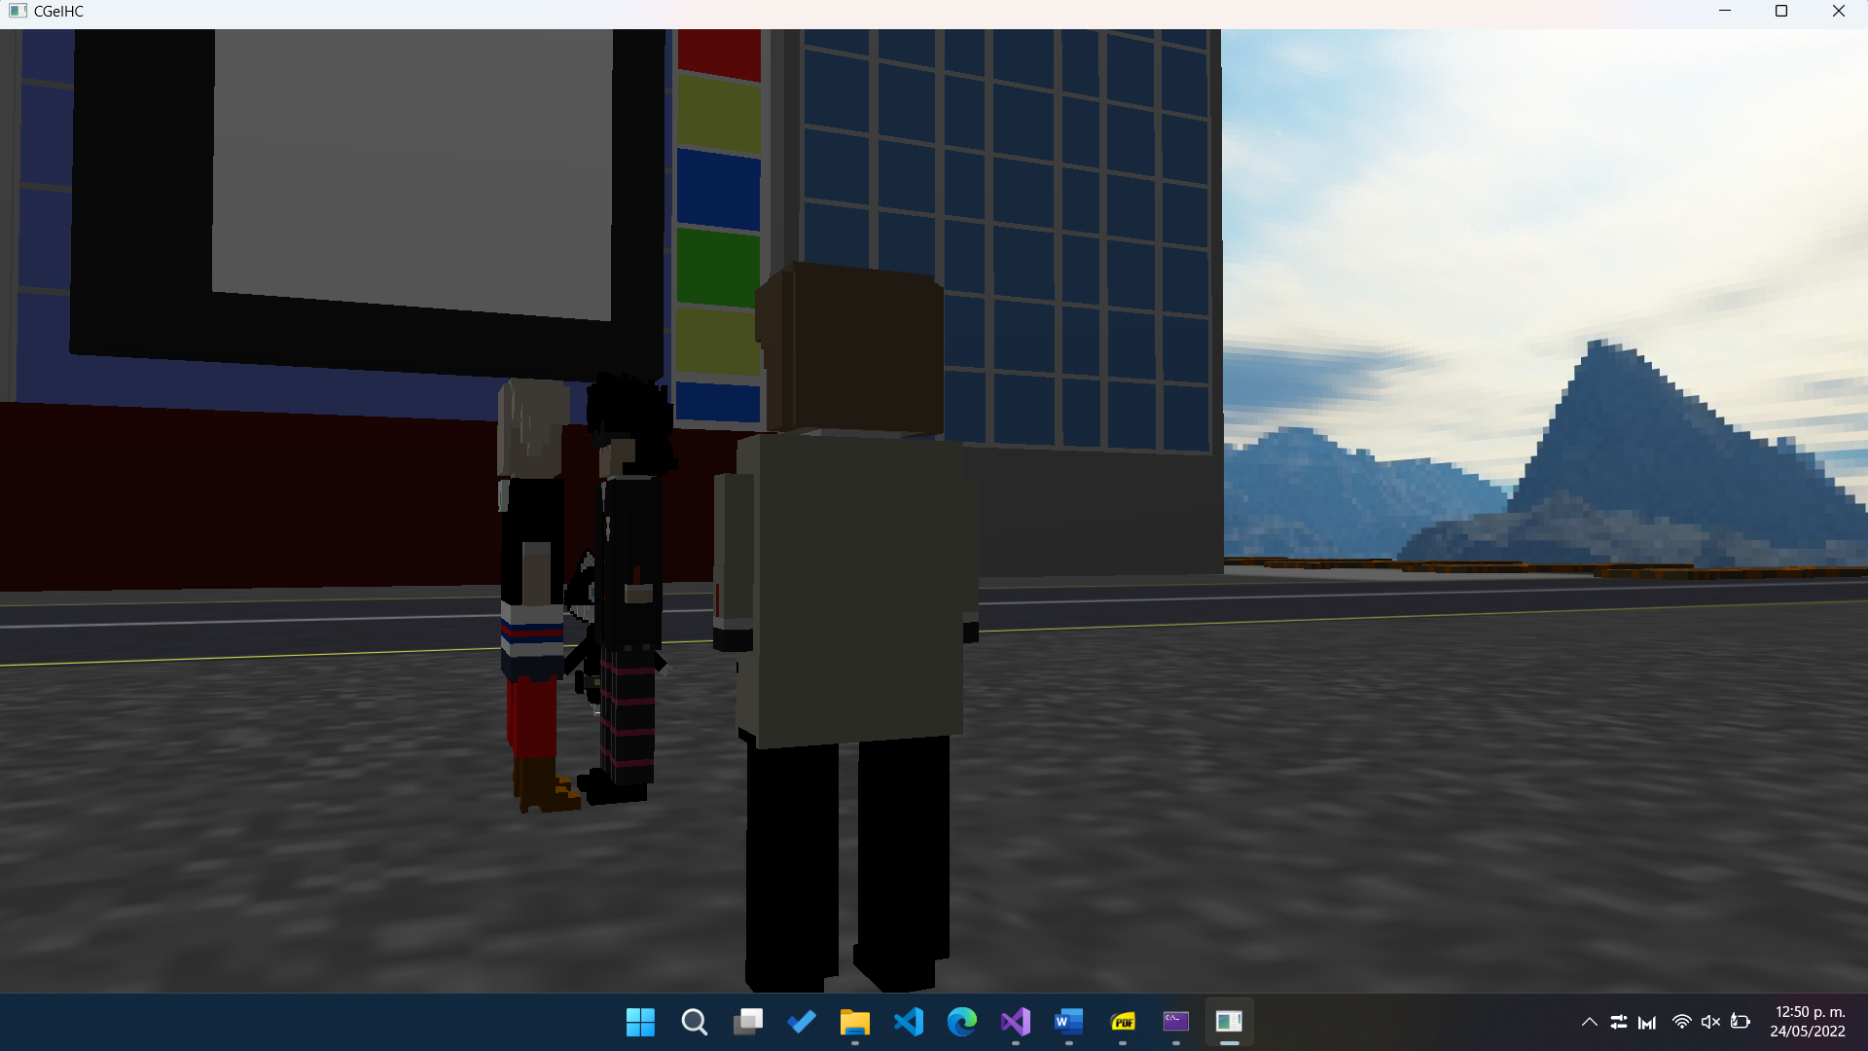

Initial position.

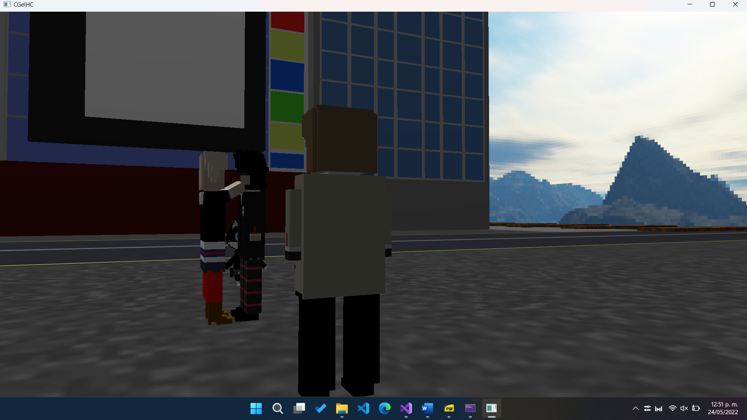

Ann with her arm raised touching Joker's head.

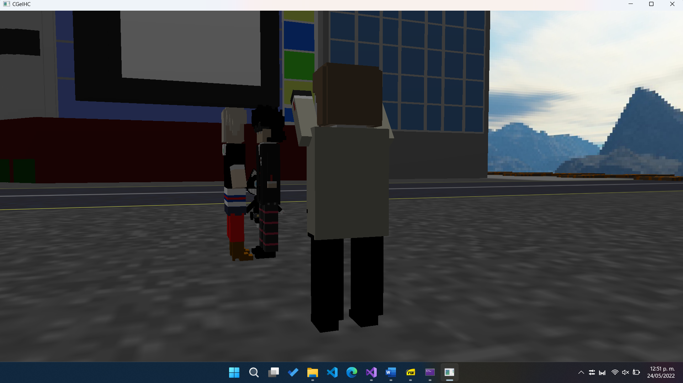

Akechi raising his arms.

## Animation 6: Speech balloons

In this animation, there are various states where speech bubbles appear above the characters, in different combinations and order. The balloons appear, rise, decrease and disappear, until they appear again and perform the same behavior. When the animation starts, a 3D audio effect coming from Morgana can be heard. This animation can be activated/deactivated with the key 6 and restarted with the P key.

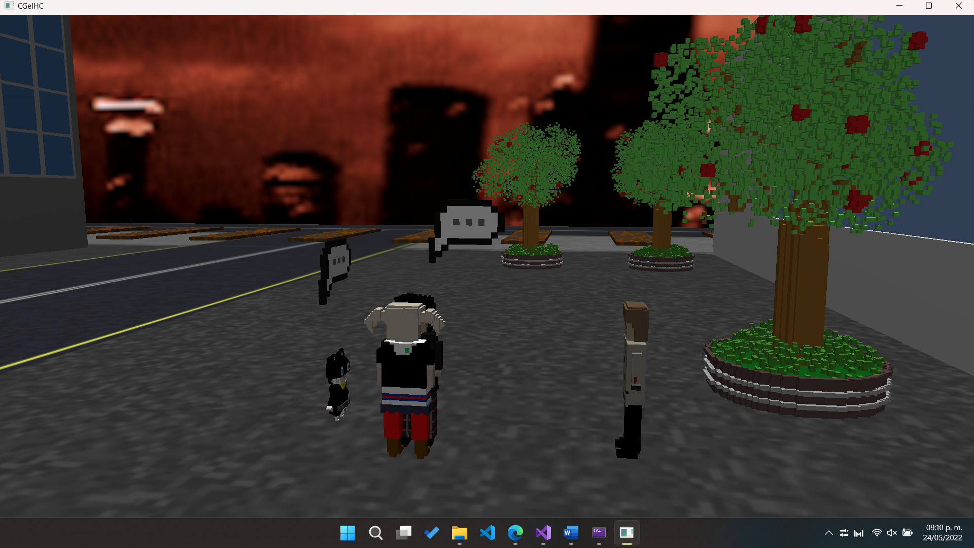

Speech balloons appearing over the characters.

## Animation 7: Shadow Morgana running in a circle on the floor

Here you can see a circle path of Morgana with its legs as if they were in a circle form. The direction it looks is according to its movement path. Likewise, its arms are raised and always in motion, as if trembling due to the speed at which it runs. This animation starts by default, but can be paused with the key 7, as well as can be stopped and restarted by pressing the L key.

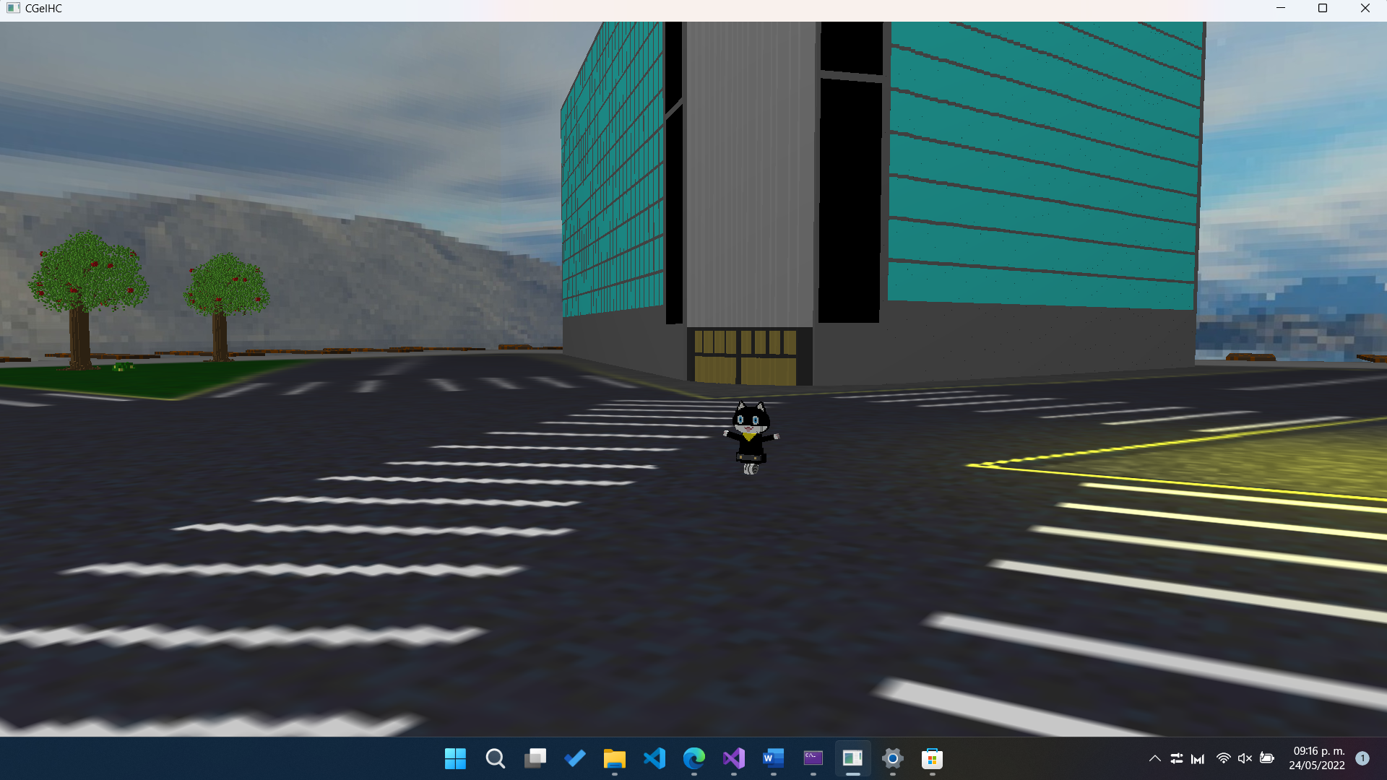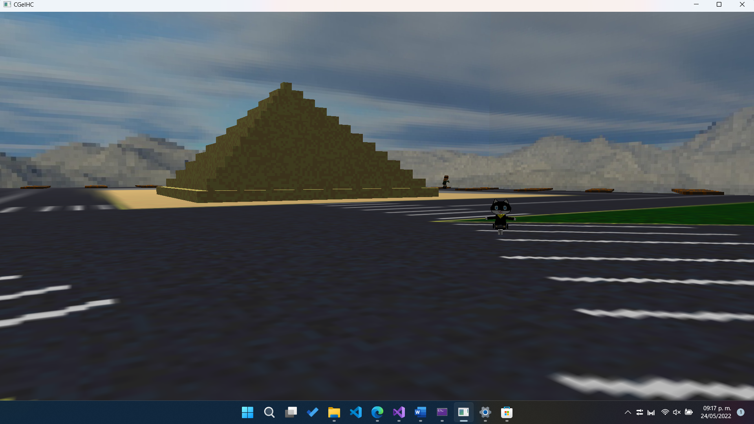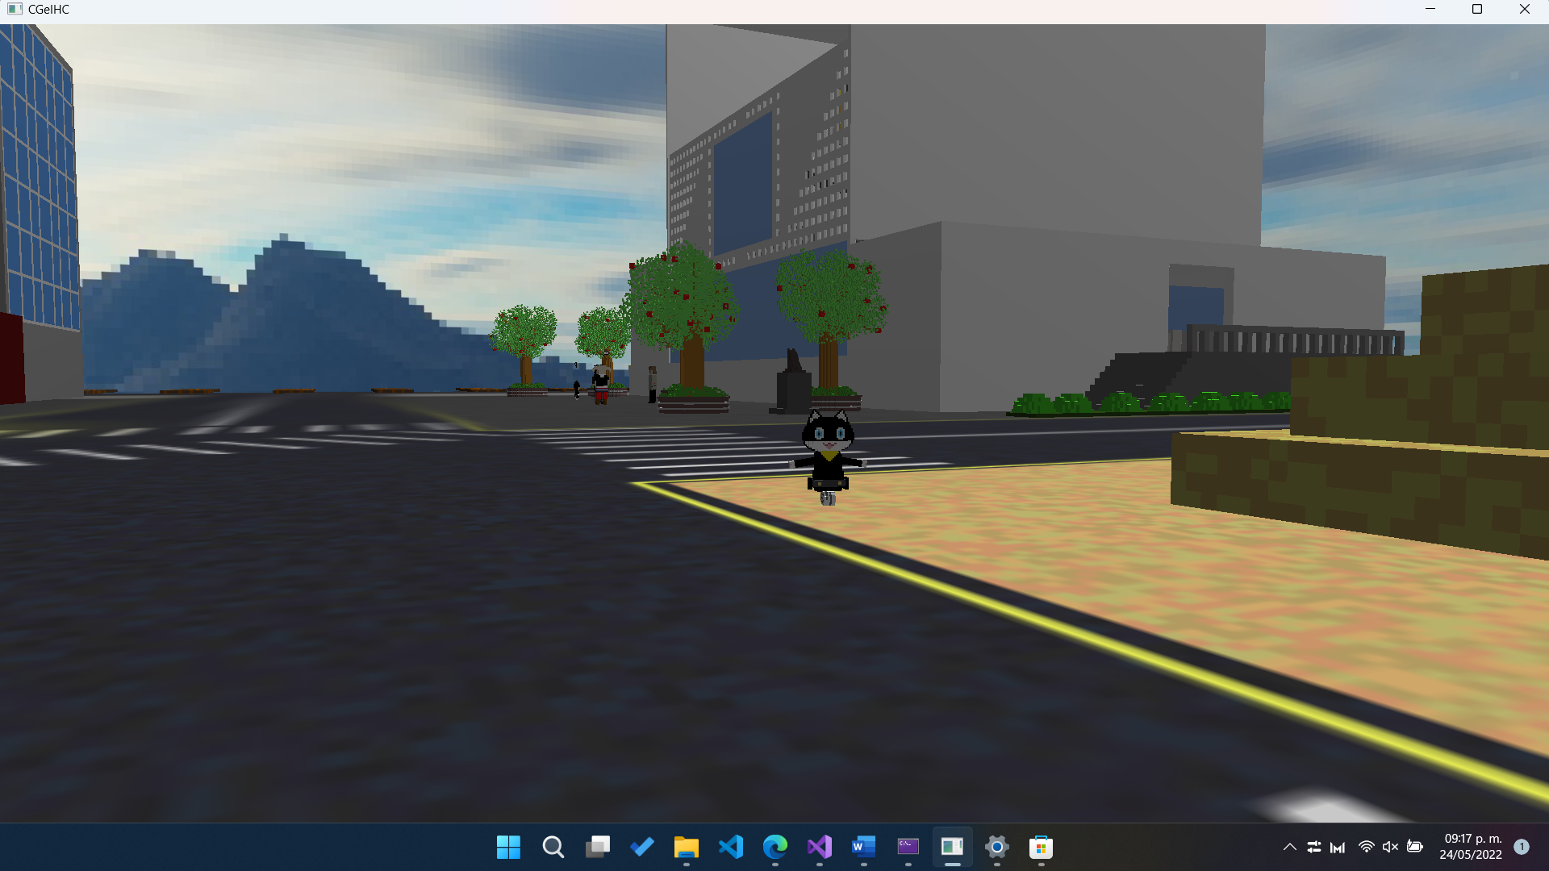

Shadow Morgana's various positions along its route.